dma+macd strategy
Introduction: this strategy is a type of momentum strategy and is trend-following, meaning that the more trendy the stock market is, the more effective this strategy is and the more it can be used to its maximum effect.

Data analysis：
As this strategy is a market that requires a strong trend, the data analysis and visualisation of the overall 10 stocks can show the market that is suitable for this strategy - i.e. there is a clear trend

- volatility analysis
Based on an analysis of the volatility of the overall data opening and closing prices, it is clear that asset number one two eight is the most volatile (risky) and number six seven ten is the least volatile (risky). (This part of the data analysis in python).
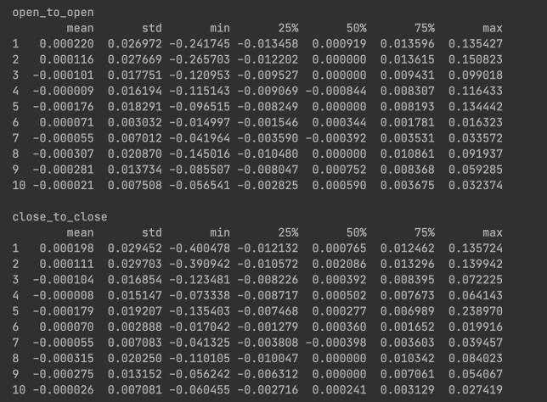

- k-chart analysis
I visualised the known 10 series of stocks using k-line charts, such as these three charts below, where a clear trend exists.
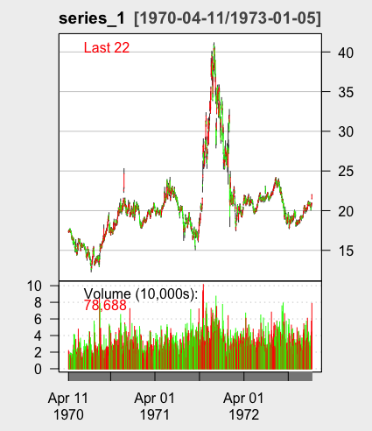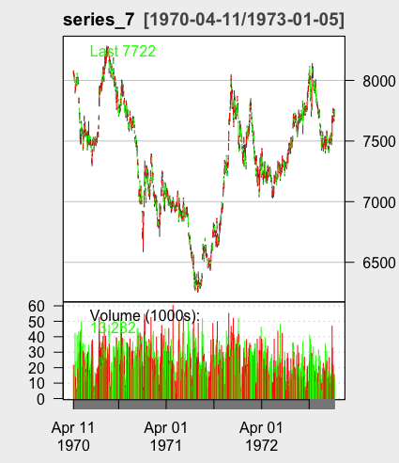

3. Trend detection
Trends in time series data were analysed using the Mann-Kendall test.
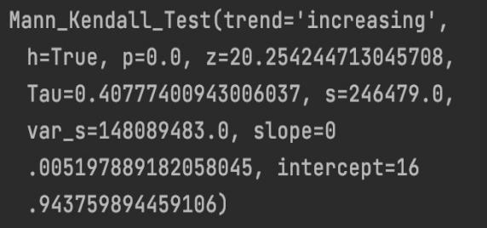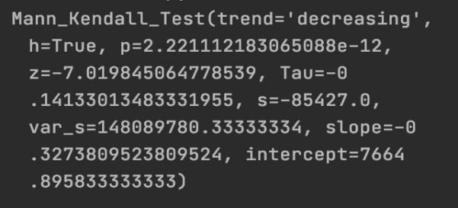
Series 1 Series 7

How the strategy works?
- Design concept
this strategy combines two simple moving average lines and MACD indicators to clearly identify buying and selling actions in trending markets.

Double Moving Averaging indicators
Firstly, I considered that if it is a trending and less volatile market, there is a great need for an index of trend indicators. Based on what I learnt in year 3 of COMP226, the first indicator that came to mind was the moving average indicator, which is a digital low-pass filter and therefore gives a visual indication of the general trend of the stock market. Next, I chose the the simple moving average (short for SMA) because I thought that all other things being equal, SMA can give a good indication of the general trend of a time series. If a clear entry signal is needed, I think two SMAs would be more convincing, and traders can obtain objective signals that reflect the strength of the market.

However, the averaging indicator also has the disadvantage of being lagging, and is often only reflected in the averages after a significant pullback in price. Frequent entries and exits in oscillating markets can lead to losses.

Moving Average Convergence/Divergence (MACD)
It is also a trend following momentum indicator. It illustrates the relationship between two exponential moving averages (EMAs) of a security's price. [2] It is worth noting that the MACD indicator uses the same concept of averaging as the SMA, but the MACD uses exponential decreasing weighting to calculate the mean, i.e. it is weighted by time on the basis of the moving average, with prices closer to the current date having a greater influence on future prices and given a greater weight, and be more sensitive to the price changes [3] Therefore, if the macd indicator is added to the entry rules, it can alleviate the lag of the SMA and eliminate the defect that the SMA sometimes send out false signals frequently, making the indicator more accurate in grasping the medium and long-term trends.[4]

In r, I called the SMA and MACD functions of the TTR package in the following code form

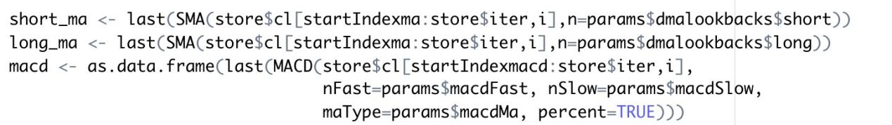
It is worth explaining that the result of macd() is a matrix containing columns, two of which are "macd" and "signal".

The basic logic of the strategy is therefore that when the short SMA crosses the long SMA and macd$macd crosses macd$signal from bottom to top, this is a clear signal to long and indicates an uptrend ahead; when the short SMA crosses the long SMA and macd$macd crosses macd$signal from top to bottom, this is a clear signal to leave or short and represents the existence of a downtrend and a short market. What’s more, if we analyze indicators, if the macd line diverges from the K line, there will have a possible reversal of the market. The crossover method represents a change in momentum and can determine the point of entry or exit into the market [1].

2) logic and code
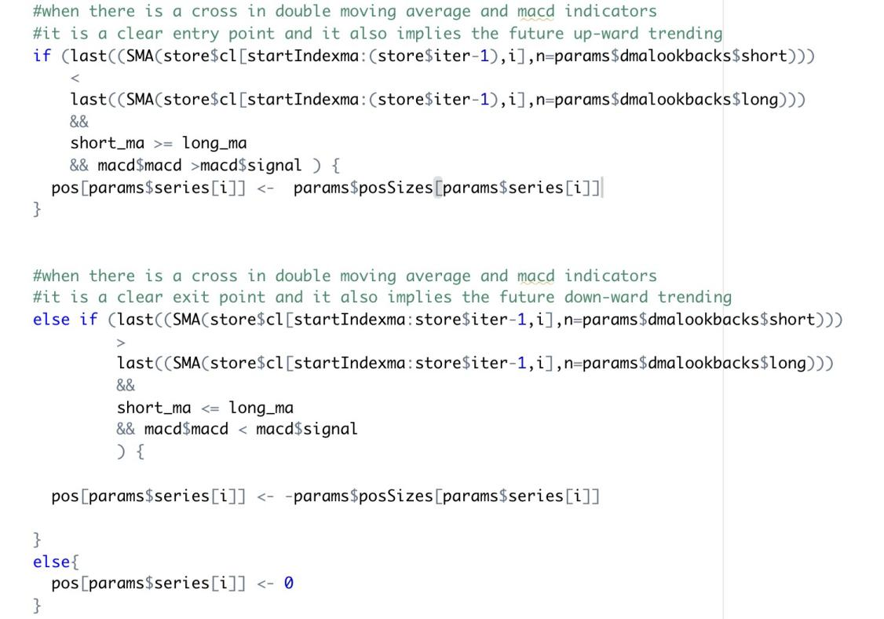
（还没写time scale，我估摸着是按日交易的）

Preliminary testing
- Initial parameter selection and optimization.
1) parameter selection
In a double SMA strategy, if the periods of the two SMAs are close together, they will be very prone to entanglement, constantly generating buy and sell points and there will be a large number of invalid trades, resulting in high trading costs. If the period of the two averages is wide apart, the trend of the averages with very long trading periods will lag as they are not obvious and there will be a lag in when buy and sell points appear, thus potentially resulting in a large loss. So for the initial two SMA lookbacks I chose 5 and 10 for the short SMA and 50 and 60 for the long SMA, while the macd parameters were chosen as default values and nFast = 12, nSlow = 26, nSig = 9 and lookback is 50.
Since this strategy is back-tested on series1 and 7, the following results are taken from stock market 1 and 7.
- parameter optimization
First, I use the data from days 1 to 500 as the training set (i.e. in sample data set), and the data from days 501 to 1000 as the test set (i.e.out-of-sample data set). In the meantime, I have used the position sizing management methodology used in COMP396 Lecture 4 to determine the extent to which individual series stocks contribute to overall profits by using the difference of open price moves. Analysis of the data shows that series7 is the benchmark and the position size for series1 is increased to 323 units.
Secondly, I used grid search to find all the combinations of parameters and cross validation to find the best combination of returns in the training set.
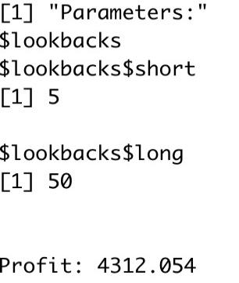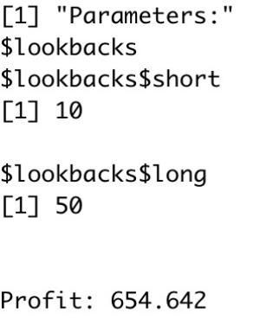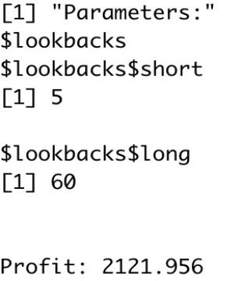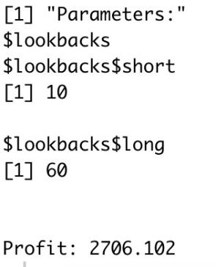
It is clear to see that the combination of parameters (5, 50) performs the best, so I used that in out-of-sample test.
The total result for series 1 and series 7 in out-of-sample is :
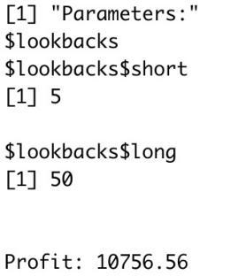

- Backtesting and results analysis
The combination of parameters resulting from the above parameter optimisation is now used for backtesting. The following diagram shows the parameters of the entire strategy.
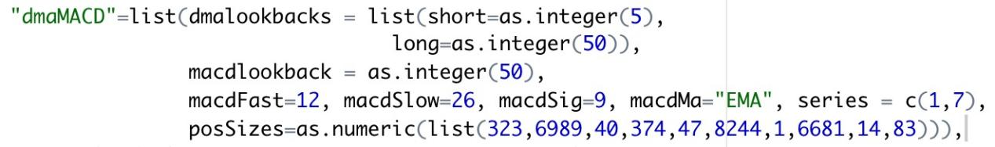
Run main.r, the following pictures are from in-sample data set.
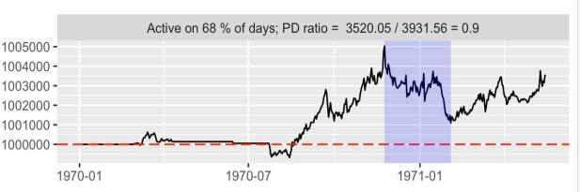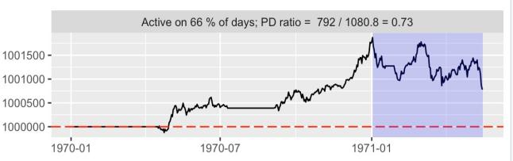
Series 1 Series 7

The following pictures are from out-of-sample data set.
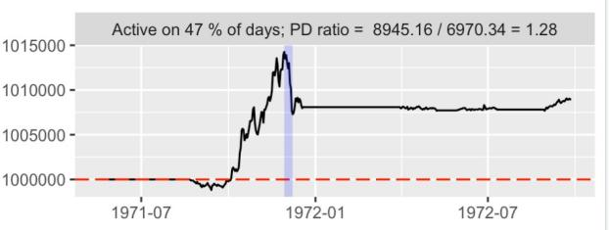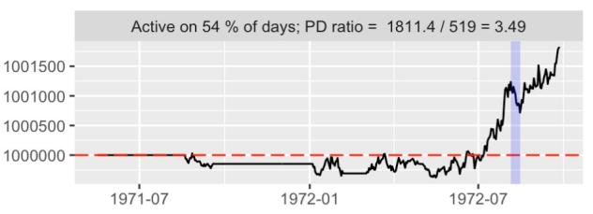
Series 1 Series 7

Plan
- overall reflection
In the code implementation of this strategy, I first considered the use of market order, not limit order, but if I wanted to make more profit with limited resources, perhaps limit order could help me to do so. However, as there are still some technical and logical problems with "how to build a limit order into the code", the whole group needs to follow up and discuss.
Secondly, as this strategy is suitable for trending markets, it does not evaluate well in mean-reversion markets and oscillating markets, and carries a high degree of risk.
Finally, based on the results of the in-sample, the retracement values are still large, suggesting that the strategy can only provide the most basic trading ideas for the time being.

- risk management solutions
Stop-loss settings.
There is no stop loss set in this strategy. Throughout the series (in sample data), the results of the oscillating market are not objective. The strategy's signals may sometimes be incorrect, and stop-loss settings are needed to avoid larger losses. For example, if in a strong trending market, a buy signal has been generated and has entered the market, but has fallen for three consecutive days and has not yet triggered a short exit signal, then a stop loss is required to clear the position and leave early. But if in a weak trend market, I need to consider a shorter period of time to determine whether there is a stop-loss exit opportunity. Therefore, in the next time, if I continue to follow this strategy, I will carefully study the stop-loss settings in different market conditions to maximize profits as much as possible.

